[Organization Name],
a [sector of activity and organization structure] in [country of operation]

Evaluation Report on
Client Protection Practices
using the Agri CP Tool

[Month Year]
cerise-sptf.org


This template should be used in conjunction with the Guidance provided for the use of the Agri CP Tool.

General Considerations and Recommendations for Writing the Agri CP Tool Report
Language | This report is written first and foremost for the organization’ management. It should initially be written in the primary formal language used for business operations and internal reporting within the organization.  After the report has been vetted internally, it can be translated into English, French, or another relevant language(s), allowing the results to be shared more easily among other stakeholders, such as investors and partner organisations.
Organization | The report should be punchy and well structured, to facilitate clarity and fast reading.
Pictures and graphics | Text should be supplemented with pictures and graphics to support arguments, provide examples, and improve readability. Pictures of farmers and the organization staff give the reader a glimpse of reality on the ground.
Length | We recommend making it a summary report, not a detailed, lengthy document! Focus on the most important information. The reader wants a quick overview of the organization’s results.
Audience | Remember the different people who will read the summary report (investors, agriculture experts, practitioners, networks, technical assistance providers, the general public) and tailor your prose so that it is suitable.

Strategy for Communication of Results
- Ask the organization management to review and validate the report. If needed and pertinent, revise the report accordingly after communicating with the management.
- Encourage the organization to disseminate the report to, among others,
- Internal stakeholders: board of directors, staff, farmer suppliers, clients
- External stakeholders: investors, donors, technical assistance providers, partner organisations, parent organisations.
- Suggest a process to the management whereby the proposed action plan can be discussed, evaluated, modified, and ultimately implemented. Potentially, other stakeholders could be involved in this process.

Notes:
The underlined areas in the template below are the fields to be filled out. The text explains what is required and how the information entered will be used.
It must be deleted and replaced with information about the organization and the details of the evaluation.
The text that is already present must be included in the final report.
These two pages may also be deleted once the report has been drafted.
Version: July 2026
Draft version, under development
Agri Client Protection Performance of [Name of the organization]
[Country, Month Year of the assessment]
[Name of the organization]
[Assessor (internal/external) - Names]
[Month Year of the report publication]
Executive Summary
[Max one page, covering:
- Who the organisation is and how it works with farmers?
- What services are provided to farmers and through which channels?
- Overall Agri CP performance (could be a graph from the dashboards), headline strengths, and headline risks/areas for improvement.
- Two or three priority actions or general areas for improvement.]

1.0 Introduction
[Briefly introduce the organization (name, country of operation, sector of activity, type of agricultural product, role in the value chain, etc., as relevant) and present the reasons for applying the Agri CP Tool, who was commissioned, where does the budget come from as well as the assessment method (self-assessment, external assessment, due diligence, technical assistance mission) = description of the evaluation context]
The Agri CP assessment was conducted using the Agri Client Protection (Agri CP) Tool, a management and assessment tool co-developed by Cerise+SPTF and IDH Farmfit Fund to adapt client protection to agricultural service delivery. The tool assesses how an agri-organization (agribusiness, farmer organization and agriculture service provider) protects smallholder farmers across all commercial/ contractual relationships/ membership—input supply, market access, financial and non-financial services, and data practices. The tool uses flexible scoping to reflect the services provided and the way they are delivered. Services may be delivered directly by the organization or through partners. Agents are not scoped separately: for assessment purposes, they are considered part of the organization’s own delivery model, similar to quasi-employees or direct representatives. Their practices and conduct should therefore be considered when assessing all relevant indicators. Built on eight Client Protection Standards (tailored from financial inclusion to smallholder agriculture), its structure is translated through Standards, Essential Practices and Indicators. The tool prioritizes priority must-haves and must-haves (including an immediate-risk-of-harm subset) alongside good practices to guide a time-bound improvement plan. The tool is intended for investors to assess and guide investees and for agri-organizations for self-assessment.
[If deemed relevant, more details on the Agri CP Tool can be added: how the tool is structured, how filters are applied, how scores are computed, etc. These details can be found in the “Agri CP Tool Guidance – When to use the tool. – and “How to conduct an assessment with the Agri CP Tool”]
This report summarises the findings of the Agri CP assessment, conducted by [name] from [DATE] to [DATE].

Description of the Organization
[Provide a brief description of the organization’ profile, context, and history, giving details not contained in the “Introduction” above, including
- General information: year of creation, legal status, nature of business, mission statement, areas of operations, number of staff, where the organization operates and what that context looks like, for example if there are many other similar service providers, or if the organization is a “sole provider”, etc.
- Business model: products, target market, number of farmer suppliers, key partners, affiliations or parent organization, certifications, etc. Please describe what services/decisions these partners take, or more generally which services are controlled by the organization, which are offered by agents (if any), and what partners are doing in collaboration. This description should give a clear picture on which services the organization controls/ where its responsible, where it can only influence (e.g. partners/service coalitions) and where it has no influence.
  - Services delivered directly by the organization
  - Services delivered via agents (agents should be considered as part of the organization’s own delivery model, similar to quasi-employees or direct representatives of the organization.)
  - Services delivered via partners (any person or legal entity, other than employees, that are contracted by the provider to develop financial services or facilitate transactions and other services for customers according to the terms of the provider.)
  - Who controls pricing, terms, and deductions in each case.
- Challenges and opportunities faced.]
Provide some economic and industry context. This will help contextualise the conditions under which the organization operates, as well opportunities and constraints in developing and implementing an action plan.
[Feel free to add some graphs to facilitate understanding the business and its context.]

Description of the evaluation methodology
[Provide information on the evaluation period and the main stages summarizing the conduct of the evaluation (specifying the number of days spent on each stage): from the documentation review (specifying which documents were reviewed), to the fieldwork phase (specifying which organization staff and clients were interviewed), and finally the report drafting phase]
2.0 Key Agri CP Results as of [month year]

Overall Agri CP Results
Provide a brief introduction and overview of the organization’s Agri CP performance, before the detailed section by standards. Does the organization perform well overall? What can explain this global performance in term of client protection? What are the organization’s key strengths? What are its critical gaps? And immediate priorities to be addressed? Use the overall results in the dashboard as pertinent.
[Insert the organization’ Agri CP Tool dashboard – example below.]
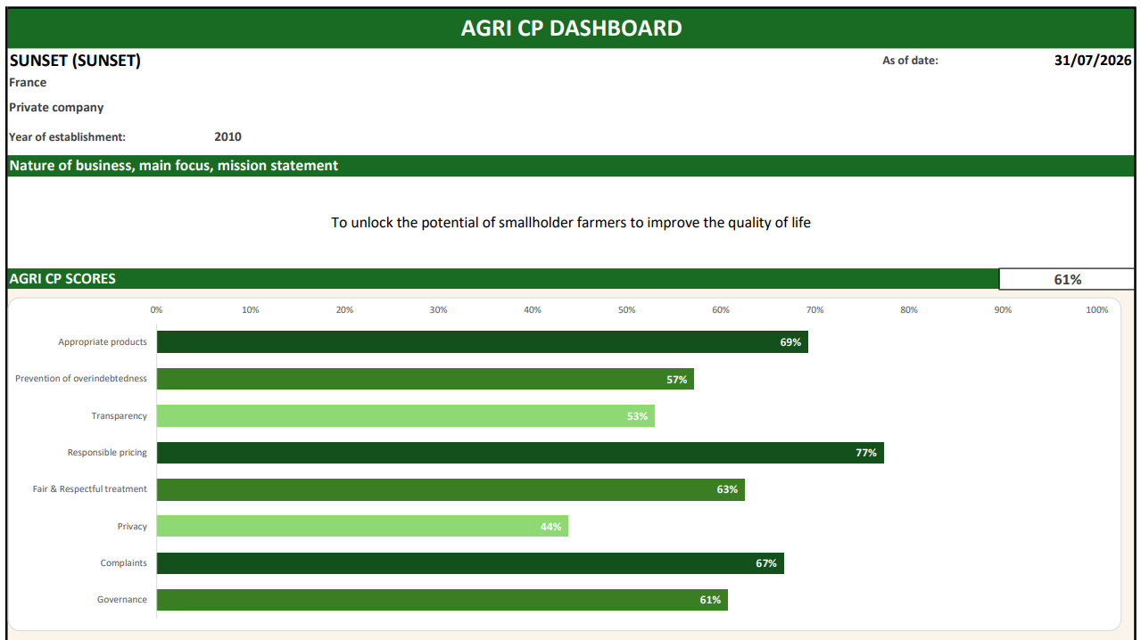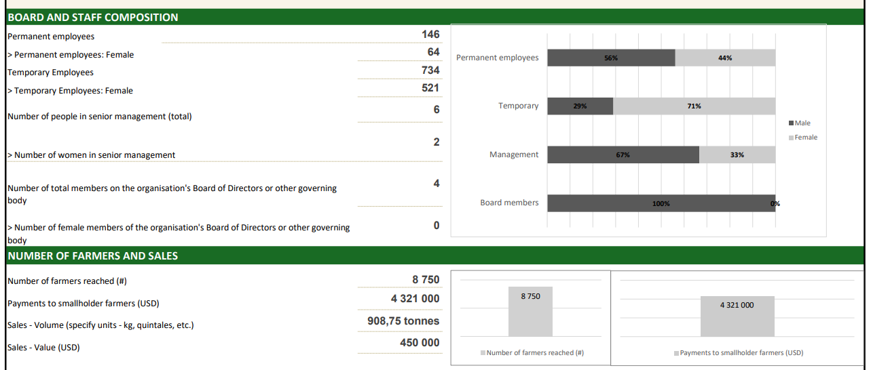

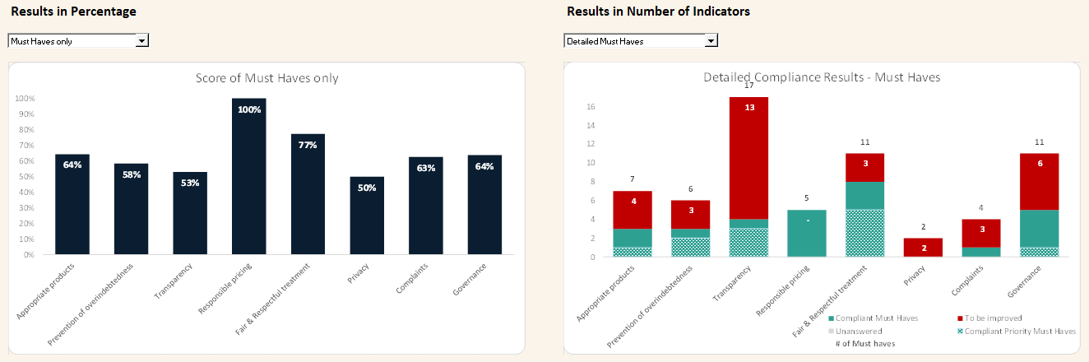
3.0 Agri CP Results by Standard
[Depth and length should be guided by materiality and risk. Higher risk and materiality should deserve more space. Per dimension you could add a short “What this means for farmers” sentence for non-experts.]
Standard 1
Appropriate products, services & channels for smallholder farmers (Average score by standard = [XX]%)
This standard requires organizations to design and deliver their offerings with and for smallholder farmers, so that they create value while preventing any harm. In concrete terms, regular farmer insights and segmentation (seasonality, access and cash flow constraints) help ensure products and channels are usable and timely; without this, farmers may be offered unsuitable packages or services that arrive at the wrong moment, increasing costs and stress. Testing/piloting before deployment and monitoring usage and benefits are essential to avoid negative outcomes such as yield losses linked to delayed or poor-quality inputs, or missed service access during critical farming periods. It also requires identifying and controlling the risks of harm by product/service/channel, prohibiting aggressive sales and forced bundling that can push farmers into commitments they cannot sustain. Finally, ensuring reliable and secure channels, and guaranteeing fair quality/weight practices with clear recourse in case of problems prevent income losses and unresolved disputes that undermine trust and livelihoods.
Rationale: Standard 1 ensures that every product, service, or channel is useful, safe, and fair for smallholder farmers.
[You may also want to include a quote from organization staff, farmers or other stakeholders or provide details on an example of good practice.]

[Picture]
[Summarize the organization’s activities and efforts to date in addressing the two Essential Practices in Standard 1.]
- Start with the positive results, i.e., those essential practices on which the organization obtained a good score, moving to poorer scores. Please sub-divided them into strengths and areas for improvement to allow for more targeted reading.
- Mention special efforts or particular circumstances that explain why the organization obtained these results and if there are any initiatives pending whose implementation will influence this score in the near future. (Examining detailed evidence and information provided in the CP Assessment section of the tool is insightful.).
- Conclude with recommendations and areas of improvement, i.e., in those essential practices (and indicators) in which the organization did not obtain a good score.
- Prioritise missing must haves; specify owner, timeline and any TA/support needed. Either address each of the essential practices in separate paragraphs or summarise the whole standard in one paragraph.
[Insert the organization’s graph results for Standard 1 – example below.]
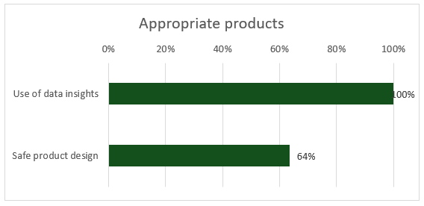

Standard 2
Prevention of overindebtedness ([XX]%)
This standard requires that all financing—whether in cash or in kind—be tailored to the actual repayment capacity of producers, taking into account agricultural cycles, stressed yields/prices, and other debts. The goal is to prevent situations where repayment obligations consume the income needed for food, health, schooling, or reinvestment, and where farmers are forced to sell assets or accept unfavourable terms to cope. In concrete terms, this involves an adequacy analysis (crop budgets, seasonal cash flows, debt verification via registers or alternative means), payment schedules aligned with the harvest, clear limits on deductions made from production purchase payments (so that deductions do not silently erode net income), and fair collection practices (without pressure or seizure of essential assets). In agricultural value chains, many loans are in-kind (inputs or services provided upfront) and are often repaid in kind at delivery, through automatic deductions from crop payments; the Tool is specifically designed to assess this modality and ensure deductions remain transparent, proportionate, and consistent with affordability. It also provides for early warning mechanisms and support solutions in the event of a shock (renegotiation, rescheduling), reducing the risk of debt spirals, informal borrowing, or systematic renewals that mask unpaid debts and keep farmers trapped in repeated cycles.
Rationale: Standard 2 aims for useful, sustainable, and responsible credit that protects the income and assets of smallholder farmers.
[You may also want to include a quote from organization staff, farmers, or other stakeholders or provide details on an example of good practice.]

[Picture]
[Summarize the organization’s activities and efforts according to the two essential practices in Standard 2.]
- Start with the positive results, i.e., those essential practices on which the organization obtained a good score, moving to poorer scores. Please sub-divided them into strengths and areas for improvement to allow for more targeted reading.
- Mention special efforts or particular circumstances that explain why the organization obtained these results and if there are any initiatives pending whose implementation will influence this score in the near future. (Examining detailed evidence and information provided in the CP Assessment section of the tool is insightful.).
- Conclude with recommendations and areas of improvement, i.e., in those essential practices (and indicators) in which the organization did not obtain a good score.
- Prioritise missing must haves; specify owner, timeline and any TA/support needed. Either address each of the essential practices in separate paragraphs or summarise the whole standard in one paragraph.
[Insert the organization’s graph results for Standard 2 – example below.]
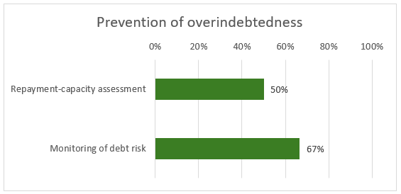

Standard 3
Clear & Timely Information ([XX]%)
This standard requires that producers receive all essential information in advance and in a comprehensible manner so that they can make an informed decision: terms and prices, deductions and penalties, quality/weight scales, payment/delivery deadlines, and refund terms. When information is incomplete or delivered too late, farmers may unknowingly accept conditions that reduce their net income (e.g., unexpected deductions), miss critical deadlines, or commit to inputs or services they cannot repay—often discovering the true cost only at harvest or payment time. It requires a Key Facts Statement (summary sheet) to be provided before any commitment is made, materials adapted to low literacy levels (local languages, visual/audio), and proof of delivery (signed contract/sheet, receipt for each transaction). The organization must ensure rapid updates in the event of changes in conditions, verify proper understanding, display information at service points, and systematically archive documents so that disputes can be resolved fairly and consistently.
Rationale: Standard 3 aims for practical transparency, without “surprises,” which allows smallholder farmers to make informed decisions.
[You may also want to include a quote from organization staff, farmers, or other stakeholders or provide details on an example of good practice.]

[Picture]
[Summarize the organization’ activities and efforts according to the two essential practices in Standard 3.]
- Start with the positive results, i.e., those essential practices on which the organization obtained a good score, moving to poorer scores. Please sub-divided them into strengths and areas for improvement to allow for more targeted reading.
- Mention special efforts or particular circumstances that explain why the organization obtained these results and if there are any initiatives pending whose implementation will influence this score in the near future. (Examining detailed evidence and information provided in the CP Assessment section of the tool is insightful.).
- Conclude with recommendations and areas of improvement, i.e., in those essential practices (and indicators) in which the organization did not obtain a good score.
- Prioritise missing must haves; specify owner, timeline and any TA/support needed. Either address each of the essential practices in separate paragraphs or summarise the whole standard in one paragraph.
[Insert the organization’s graph results for Standard 3 – example below.]
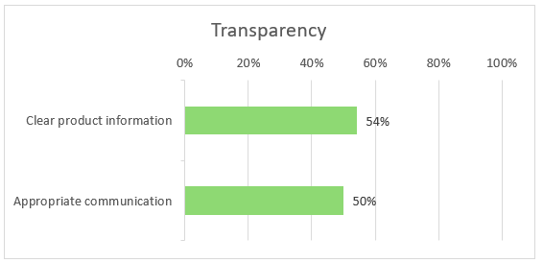

Standard 4
Responsible Pricing ([XX]%)
This standard requires that prices, fees, and deductions (on inputs, services, and production purchases) be fair, transparent, and verifiable. When pricing is unclear or not controlled, farmers can be harmed through hidden costs, unpredictable deductions, or unfair grading/weights that reduce net income—often at the moment they are most cash-constrained—undermining trust and pushing households to cope through distress sales or additional borrowing. It requires a documented pricing methodology (market/regulatory references, periodic reviews); no hidden fees and no retroactive changes (clear advance notice); publication/display of price lists and communication of an anticipated net price before each transaction. For production purchases: explicit grades/quality, calibrated scales with calibration records, complaints/correction procedures, and compensation in case of error, so that payment reflects what was actually delivered. For inputs and loans in kind: fair valuation of goods/services provided, deduction limits (or written consent) and total effective cost detailed and consistent with the key information sheet, preventing “silent” overcharging through bundled services. Partners apply the same rules, without incentives that encourage abusive practices; payments to producers are made on time. The system is monitored (disputes, market deviations, internal audits/controls) and linked to the complaints mechanism.
Rationale: Standard 4 aims for fair, predictable, and controlled prices and deductions that protect the income of smallholder farmers.
[You may also want to include a quote from organization staff, farmers or other stakeholders or provide details on an example of good practice.]

[Picture]
[Summarize the organization’ activities and efforts according to the two essential practices in Standard 4.]
- Start with the positive results, i.e., those essential practices on which the organization obtained a good score, moving to poorer scores. Please sub-divided them into strengths and areas for improvement to allow for more targeted reading.
- Mention special efforts or particular circumstances that explain why the organization obtained these results and if there are any initiatives pending whose implementation will influence this score in the near future. (Examining detailed evidence and information provided in the CP Assessment section of the tool is insightful.).
- Conclude with recommendations and areas of improvement, i.e., in those essential practices (and indicators) in which the organization did not obtain a good score.
- Prioritise missing must haves; specify owner, timeline and any TA/support needed. Either address each of the essential practices in separate paragraphs or summarise the whole standard in one paragraph.
[Insert the organization’s graph results for Standard 4 – example below.]
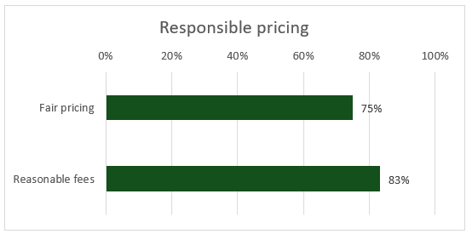

Standard 5
Fair & Respectful Treatment of Stakeholders ([XX]%)
This standard imposes zero tolerance for any form of coercion, intimidation, harassment, or abuse, and guarantees dignified, non-discriminatory relationships (gender, age, disability, origin, status) at every point of contact—farm visits, collection centers, agents, digital channels. When respectful treatment is not enforced, farmers can be harmed through pressure to sign, deliver, or repay; fear of retaliation; humiliation at service points; or exclusion of vulnerable groups, which undermines trust and can deter access to services and markets. It prohibits the retention of identity documents or essential assets, pressure to sign or deliver, and any retaliation related to a complaint. The organization implements a clear code of conduct (applicable to employees, agents, and partners), regular training, and effective disciplinary mechanisms; It secures service locations (lighting, crowd management, appropriate hours) and deploys specific GBV safeguards when the context requires it. Agents/subcontractors are contractually required to comply with these requirements and are subject to active supervision (inspections, mystery visits, complaint follow-up). Finally, incidents are recorded, processed, and analyzed to quickly correct practices and prevent their recurrence.
Rationale: Standard 5 ensures safe, respectful, and equitable interactions, which are essential for building lasting relationships of trust with smallholder farmers.
[You may want to include a quote from one of the farmers or other stakeholders or provide details on an example of good practice.]

[Picture of farmers]
[Summarize the organization’s activities and efforts according to the three essential practices in Standard 5.]
- Start with the positive results, i.e., those essential practices on which the organization obtained a good score, moving to poorer scores. Please sub-divided them into strengths and areas for improvement to allow for more targeted reading.
- Mention special efforts or particular circumstances that explain why the organization obtained these results and if there are any initiatives pending whose implementation will influence this score in the near future. (Examining detailed evidence and information provided in the CP Assessment section of the tool is insightful.).
- Conclude with recommendations and areas of improvement, i.e., in those essential practices (and indicators) in which the organization did not obtain a good score.
- Prioritise missing must haves; specify owner, timeline and any TA/support needed. Either address each of the essential practices in separate paragraphs or summarise the whole standard in one paragraph.
[Insert the organization’s graph results for Standard 5 – example below.]
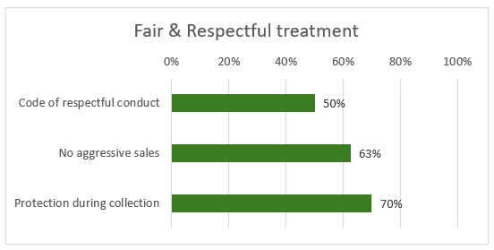

Standard 6
Data Privacy and Rights ([XX]%)
This standard requires the organization to collect and process data in a lawful, fair, and transparent manner, gathering only what is necessary for clearly explained purposes (minimization, defined retention period, secure deletion). When data is collected or shared without clear consent and safeguards, farmers can be harmed through loss of privacy, unwanted profiling, exclusion from services, fraud or identity misuse, and misuse of sensitive information (e.g., location, biometrics, financial details) that may expose them to security or reputational risks. Producers are informed simply of what is collected, why, for how long, with whom it is shared, and their rights (access, rectification, withdrawal of consent where applicable, complaint) via a privacy notice shared prior to any collection. Security is ensured by access controls (role-based rights), passwords/MFA, encryption and backups, device management (remote locking, wiping), physical storage under lock and key, and logging of access; third-party service providers/agents are covered by sharing/processing agreements limiting uses and prohibiting any unauthorized resale or transfer. Sensitive data (biometrics, precise location, financial information) is subject to enhanced safeguards. A designated manager oversees level of implementation, team training, and an incident response plan (detection, recording, notification, and remediation).
Rationale: Standard 6 guarantees secure, useful, and controlled data, and smallholder farmers who are informed and able to exercise their rights.
[You may want to include a quote from organization staff, farmers, or other stakeholders or provide details on an example of good practice.]

[Picture]
[Summarize the organization’ activities and efforts according to the two essential practices in Standard 6.]
- Start with the positive results, i.e., those essential practices on which the organization obtained a good score, moving to poorer scores. Please sub-divided them into strengths and areas for improvement to allow for more targeted reading.
- Mention special efforts or particular circumstances that explain why the organization obtained these results and if there are any initiatives pending whose implementation will influence this score in the near future. (Examining detailed evidence and information provided in the CP Assessment section of the tool is insightful.).
- Conclude with recommendations and areas of improvement, i.e., in those essential practices (and indicators) in which the organization did not obtain a good score.
- Prioritise missing must haves; specify owner, timeline and any TA/support needed. Either address each of the essential practices in separate paragraphs or summarise the whole standard in one paragraph.
[Insert the organization’s graph results for Standard 6 – example below.]
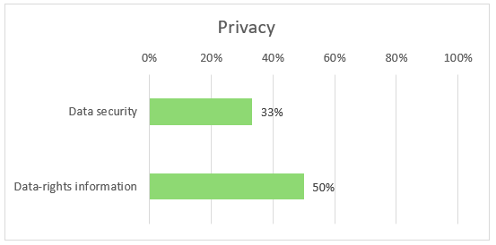

Standard 7
Effective Complaints Management ([XX]%)
This standard requires a secure, accessible, and trustworthy complaints mechanism to address grievances related to operations, employees, agents, products, and services, originating from smallholder farmers, local communities, and any other affected parties. When complaints are not received or handled safely, harm can persist unnoticed—farmers may avoid speaking up for fear of retaliation, problems may repeat (e.g., unfair deductions, abusive behaviour, faulty inputs), and unresolved grievances can escalate into loss of income, conflict, or reputational and legal risks for the organization. In practical terms, the organization provides several channels that are free of charge, in local languages, and adapted to low literacy levels, with confidentiality, anonymity options, and a no-retaliation policy. Decisions are notified to complainants and, in the event of harm, effective remediation is offered (correction of practice, replacement/compensation, disciplinary measures). The system also covers agents/subcontractors (contractual clauses, supervision, reporting), is visible at service points (clear signage), and is monitored by indicators, with trend analysis by the management committee and continuous improvement.
Rationale: Standard 7 ensures that any justified criticism is translated into a response and redress, while feeding into organizational learning.
[You may want to include a quote from organization staff, farmers, or other stakeholders or provide details on an example of good practice.]

[Picture]
[Summarize the organization’s activities and efforts according to the three essential practices in Standard 7.]
- Start with the positive results, i.e., those essential practices on which the organization obtained a good score, moving to poorer scores. Please sub-divided them into strengths and areas for improvement to allow for more targeted reading.
- Mention special efforts or particular circumstances that explain why the organization obtained these results and if there are any initiatives pending whose implementation will influence this score in the near future. (Examining detailed evidence and information provided in the CP Assessment section of the tool is insightful.).
- Conclude with recommendations and areas of improvement, i.e., in those essential practices (and indicators) in which the organization did not obtain a good score.
- Prioritise missing must haves; specify owner, timeline and any TA/support needed. Either address each of the essential practices in separate paragraphs or summarise the whole standard in one paragraph.
[Insert the organization’s graph results for Standard 7 – example below.]
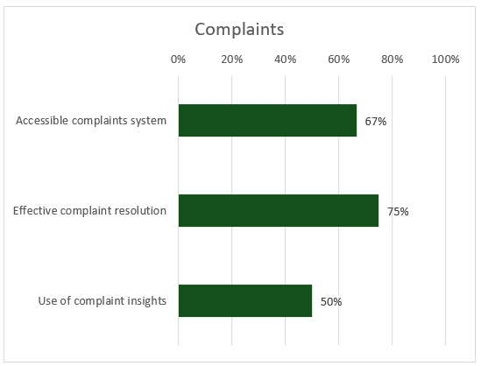

Standard 8
Governance & HR Commitment ([XX]%)
This standard requires an explicit and verifiable commitment from management and the board of directors to protect smallholder farmers, translated into governance, resources, and systems. Without clear ownership, incentives, and oversight, client protection can become inconsistent—especially when services are delivered through agents and partners—allowing harmful practices (e.g., abusive deductions, aggressive sales, poor complaint handling) to persist unchecked and creating significant operational, reputational, and legal risks. In concrete terms: a policy approved at the highest level; a designated manager (with a mandate, budget, and annual plan); the integration of Agri CP requirements into strategy, risk management, committees (credit/purchasing/quality), management reviews, and internal audits. HR supports implementation through a code of conduct, contractual clauses applicable to staff/agents/partners, training (onboarding + refresh), and aligned incentives (targets that do not encourage aggressive sales or abusive deductions), accompanied by a disciplinary mechanism and an ethics alert system. Partners/agents are subject to due diligence, contracts incorporating Client Protection requirements, and documented supervision (controls, audits, corrective plans). A dashboard tracks KPIs (training, incidents, complaints, resolution times, audit closures), feeds into corrective decisions and a cycle of continuous improvement (annual review, procedure updates).
Rationale: Standard 8 ensures that the protection of smallholder farmers is driven by governance, supported by HR, and effectively managed throughout the organization and its execution chain.
[You may want to include a quote from organization staff, farmers, or other stakeholders or provide details on an example of good practice.]

[Picture]
[Summarize the organization’s activities and efforts according to the four essential practices in Standard 8.]
- Start with the positive results, i.e., those essential practices on which the organization obtained a good score, moving to poorer scores. Please sub-divided them into strengths and areas for improvement to allow for more targeted reading.
- Mention special efforts or particular circumstances that explain why the organization obtained these results and if there are any initiatives pending whose implementation will influence this score in the near future. (Examining detailed evidence and information provided in the CP Assessment section of the tool is insightful.).
- Conclude with recommendations and areas of improvement, i.e., in those essential practices (and indicators) in which the organization did not obtain a good score.
- Prioritise missing must haves; specify owner, timeline and any TA/support needed. Either address each of the essential practices in separate paragraphs or summarise the whole standard in one paragraph.
[Insert the organization’s graph results for Standard 8 – example below.]
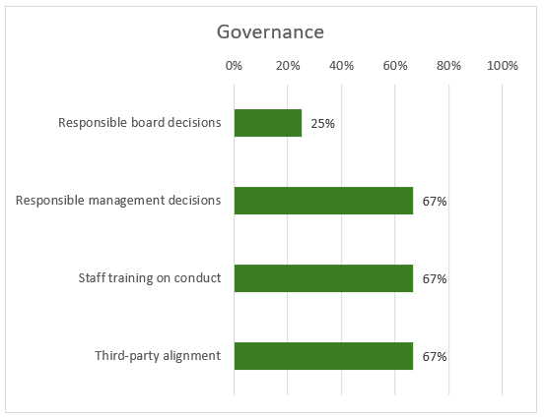

4.0 Conclusion and Recommendations
[Summarize the organization’s main strengths—especially where current practices already protect smallholder farmers (SHFs) and create value—then identify two or three Agri CP priorities only. Select priorities that:
- (i) close first Priority Must-Have gaps and then Must-Have gaps,
- (ii) have the greatest impact on farmer protection and business performance,
- (iii) are feasible within the organization’s budget and capacity.
- For each priority, propose 1–3 concrete actions, and sequence quick wins ahead of system changes.
- Note any dependencies with agents and partners and context constraints (market rules, infrastructure) that could limit implementation; where barriers fall outside the organization’s control, add targeted asks to investors/funders (TA, de-risking, tools) or public authorities (weights/measure calibration, consumer transparency, data protection enforcement).
- Close by stating how progress will be tracked (dashboard, management/board reviews) and the date of the next Agri CP review, so the improvement plan feeds directly into the next business plan.
It may also be useful to consider the wider context: e.g., proposed changes might be restricted or difficult to implement because of a challenging business environment or government restrictions. This could lead to recommendations to other stakeholders, e.g., the government or investors in the organization.]

Action Plan Proposal
[Based on the results of the Agri CP tool, the major challenges of the local context, the organization’s strategic priorities, and its willingness and ability to allocate a budget for improvements, the auditors must jointly develop an Agri CP action plan that identifies all key areas for improvement, aligning them with the 8 standards. To do this, we encourage you to use the Cerise+SPTF Action Plan Template.
Each action must specify:
- the Agri CP standard and the corresponding “essential” tag,
- the various steps corresponding to the actions to be implemented
- a timeline, ideally over one year for a short-term action plan, and over three to five years for a long-term action plan
- the expected results for each action / the key performance indicators (KPIs) for verification
- a clearly identified person in charge, along with their corresponding department,
- the action’s priority level, ranging from a “quick win” (an action that can be implemented quickly with a large impact) to a medium or even long-term priority
- a deadline to monitor the action’s completion within the specified timeline
- the level of effort required to implement this action (in terms of the HR and financial resources needed to ensure its implementation)
- and finally, an estimate of the budgetary cost this action might entail / the budget available for carrying out this action, if possible
The action plan must be prioritized based on importance and feasibility, starting with high-impact, low-cost actions that yield quick gains, before considering systemic changes. It must prioritize client protection indicators that are “Priority Must-Haves” not yet met by the organization, followed by “Must-Haves” in a second phase.
All dependencies on staff and partners, as well as contextual constraints, should be documented; when solutions fall outside the organization’s scope of authority, targeted requests addressed to investors, technical assistance providers, or authorities must be included. Finally, the action plan must be reviewed by senior management to secure their buy-in and approval for its integration into the next budget cycle, along with a monitoring schedule (dashboard, management/board reviews) and a date for the next Agri CP evaluation.]

